PRESENTING CLINICAL SIGNS
History: Lethargic. Previous history of pancreatitis and IBS.
Physical Examination: N/A.
Urinalysis: N/A
CBC: N/A.
Serum Biochemistry: N/A.
Radiographic Findings: N/A.

ULTRASONOGRAPHIC EXAMINATION OF THE ABDOMEN
Urinary System
Full urinary bladder with a normal thickness and appearance of the wall. Small amount of floating hyperechogenic sediment present. No uroliths evident.
Normal trigone area, proximal urethra (0.3 cm), and iliac blood vessels.
Normal iliac lymph nodes. Ureters not visualized.
Renomegaly (left 4.4 cm, right 5 cm), with increased echogenic appearance, some loss of cortico-medullary differentiation, and normal pelvis and capsule.
Reproductive System
N/A.
Adrenal Glands
Normal position, echogenic appearance, shape, and size. Left 0.5 cm, right 0.48 cm.
Spleen
Normal size (0.8 cm) and echogenic appearance. Smooth homogenous parenchyma, regular curvilinear capsule, and normal vasculature. No evidence of inflammatory, neoplastic, infarction, or infiltrative changes noted.
Liver
Normal size, echogenic appearance, portal markings, and regular curvilinear capsule. No nodules or masses evident. Full gall bladder containing small amount of hyperechogenic sediment. Thickened and hyperechogenic appearance of the gall bladder wall. Normal bile duct (0.2 cm).
Gastrointestinal
Normal appearance of the stomach, duodenum, ileo-cecal junction, and colon with no loss of layering, normal wall thickness (stomach 0.19 cm, duodenum 0.27 cm, colon 0.18 cm) and peristaltic activity. Irregular hypoechogenic solid jejunal mass (1.4 x 3.9 cm) with evidence of intestinal obstruction and a hyperechogenic appearance of the mesentery surrounding the mass. Thickening of the small intestine (0.36 cm) with no loss of layering.
Pancreas
Normal size (right 0.6 cm) and echogenic appearance. Regular capsule. Normal echogenic appearance of the mesentery and fat surrounding the pancreas.
Free Abdomen
Mesenteric lymphadenomegaly (0.3 x 2.7 cm) with normal shape and echogenic appearance.
No ascites.

ULTRASONOGRAPHIC FINDINGS
Primary Findings:
- Small intestinal mass.
- Renomegaly.
- Mesenteric lymphadenomegaly.
- Enteropathy.
Secondary Findings:
- Previous cholecystitis.
- Urinary bladder sediment.

INTERPRETATION OF THE FINDINGS & FURTHER RECOMMENDATIONS
The most likely etiology for the small intestinal mass would be neoplasia (lymphoma, carcinoma) with granuloma a differential diagnosis.
Etiologies for the renomegaly would be acute kidney injury (toxins, hypoxia), bacterial nephritis, granulomatous disease, and lymphoma.
Etiologies for the lymphadenopathy would be reactive, lymphadenitis, and infiltrative neoplasia.
Etiologies for the enteropathy would be inflammatory bowel disease, dietary hypersensitivity, and parasitic enteritis.
Further assessment would be urine and fecal analyses, urine culture, 3-view thoracic radiographs, serum biochemistry, and FNA cytology of the intestinal mass and lymph nodes. As there is evidence of intestinal obstruction, laparotomy would be indicated, which could be both diagnostic and therapeutic and also allowing for intestinal and lymph node biopsies.
Specific therapy would be dependent on an etiological diagnosis.

IMAGES
Small intestinal mass
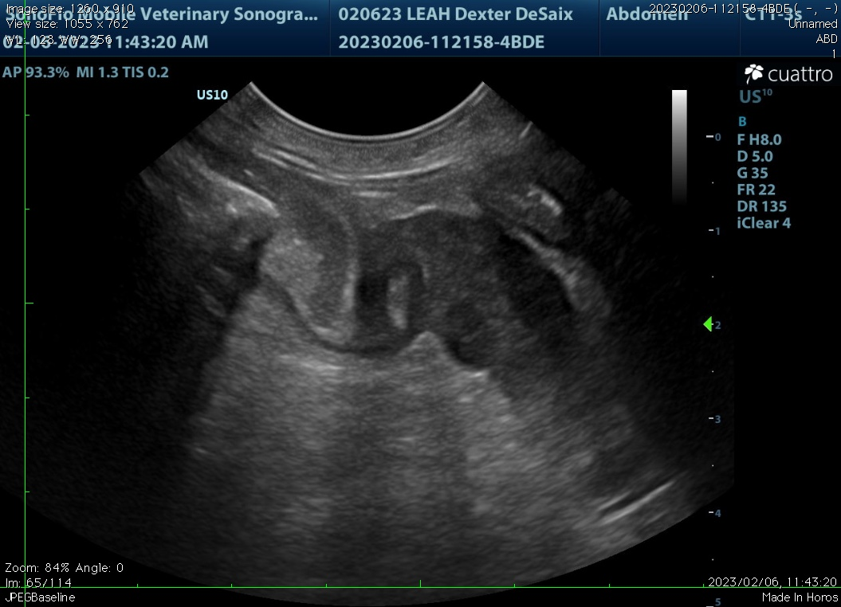
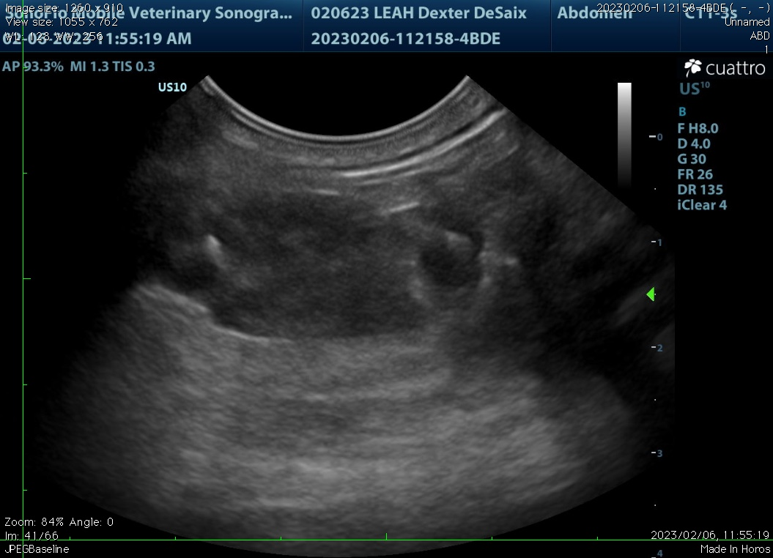

Gall bladder
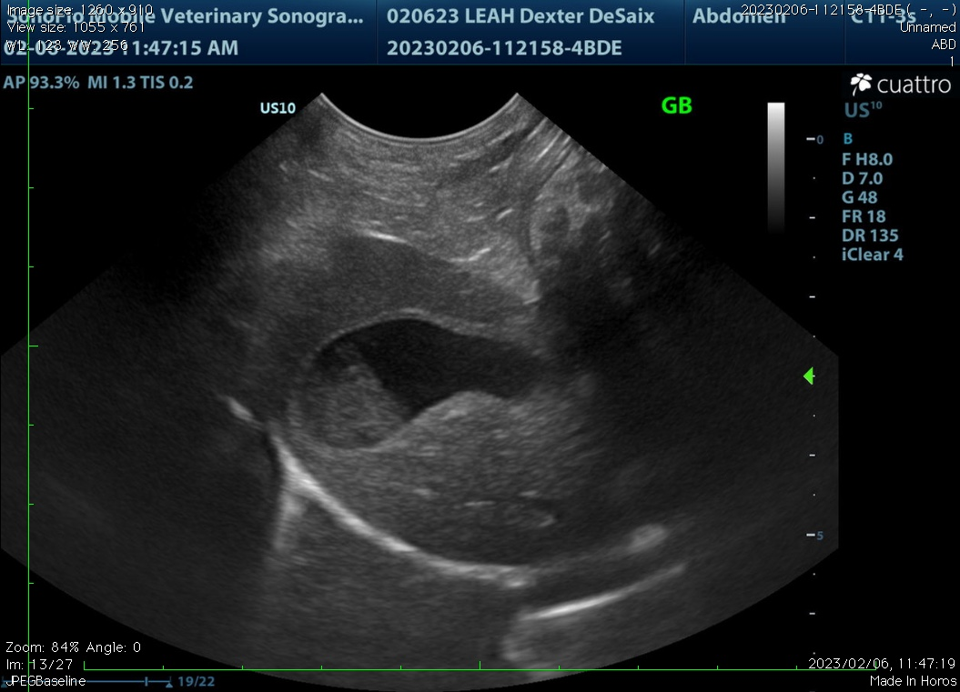

The information and recommendations provided are based on the images presented by the referring veterinarian. No evaluation can be communicated regarding pathology that was not visible in the image/video clips provided.

Thank you for this referral. If the clinical or image interpretation does not parallel your findings or if I can be of any further assistance, please contact me.

Remo Lobetti, BVSc, MMedVet (Med), PhD, Dipl. ECVIM (Internal Medicine)
rlobetti@mweb.co.za

